PROJECT REPORT

Topic: Gender Prediction from Full Name (First Name + Last Name) using Logistics Regression Model

Introduction
The project is developed to predict gender (Male or Female) from a person’s full name, including first name and last name, using Machine Learning techniques. In this project, two datasets have been used consisting of Indian and foreign names along with their corresponding genders, collected from Kaggle. The datasets have been preprocessed and trained the model. In this project, the Logistic Regression model has been used for classification, while the TF-IDF N-gram technique has been used to extract meaningful text patterns from names, helping improve prediction accuracy.

Objectives:
- To predict gender (Male/Female) using a person’s full name, first name, and last name.
- To preprocess the datasets by handling non-English characters, normalization, and outlier text size for better model performance.
- To train and evaluate the Machine Learning model using Logistic Regression and TF-IDF N-gram techniques for accurate gender prediction.

Methodology

Step 1: Data Collection
- The dataset contains names along with their corresponding gender labels (Male/Female).
- It includes both Indian and foreign names for better diversity and accuracy.
- The dataset has been collected from Kaggle.
- It is used for training and evaluating the machine learning model for gender prediction.
- The data helps the model learn patterns in names associated with different genders.
- Datasets Link with Size:

File Name | Size | Link
data.csv | 3687 KB | Data Link
Gender_Data.csv | 635 KB | Data Link

Step 2: Data Preprocessing
- Collected and combined Indian and foreign name datasets.
- Removed missing and duplicate values from the datasets.
- Handled non-English characters and special symbols.
- Applied text normalization by converting names into a standard format.
- Managed outlier text sizes by filtering very short or very long names.
- Convert all text into lowercase for consistency.
- Prepared the cleaned data for feature extraction and model training.

Step 3: Feature Engineering
- Names are converted into numerical format using TF-IDF Vectorization.
- We choose analyzer as character to analyze names at the character level instead of word level.
- Character-level N-grams are used (2–5 range) to capture meaningful patterns in names.
- The TF-IDF technique helps identify important character combinations for gender prediction.
- Feature vectors generated from names are used as input for the Machine Learning model.

Step 4: Model Training
- Algorithm used: Logistic Regression for classification.
- The model uses probability estimation to classify names into Male or Female.
- Class imbalance is handled by setting the class parameter as balanced to improve fairness in predictions.
- The dataset is split into 80% training data and 20% testing data.
- Maximum iterations are set to 2000 to ensure proper convergence of the model.

Step 5: Prediction Logic
- The trained model predicts the probability for each class (Male and Female).
- The final prediction is based on the highest probability score.
- Confidence levels are assigned based on probability values:
- Low Confidence: (< 0.55) – Uncertain prediction
- Medium Confidence: (0.55 – 0.70) – Moderately reliable prediction
- High Confidence: (> 0.70) – Strong and reliable prediction

Technologies Used
- Logistic Regression:
- We used a supervised Logistic Regression model for predicting gender (Male and Female) using full names.
- The model is trained using an 80% training set and 20% testing set to ensure proper evaluation and avoid overfitting.
- Class imbalance is handled using a balanced class approach so that both gender classes are treated equally.
- The model is configured with a maximum iteration limit of 2000 to ensure proper convergence during training.
- Predictions are made using probability scores to understand the confidence of the model.
- Performance is evaluated using accuracy score and classification report for detailed analysis of precision, recall, and F1-score.

- TF-IDF Vectorization (Feature Extraction)
- We used TF-IDF (Term Frequency–Inverse Document Frequency) technique to convert names into numerical features because machine learning models cannot work directly with text data.
- It helps in giving more importance to unique and meaningful character patterns in names while reducing the weight of common patterns.
- We use character-level analysis
- N-grams in the range of 2 to 5 are used to capture both small and slightly longer character sequences.
- This technique improves model accuracy by representing names in a structured numerical format.

Model Performance / Results
- We evaluate the model using accuracy scores to measure overall correctness of predictions.
- The model achieved an accuracy of 89%(approx), indicating good performance in gender prediction from full names.
- The results show that the model performs effectively in predicting gender from full names.
- The model takes approximately 13 seconds to run and complete training, showing efficient processing time.
- Additionally, probability scores are calculated to show the confidence level of each prediction.
- A classification report is used to analyze precision, recall, and F1-score for both Male and Female classes.
- The results show that the model performs effectively in predicting gender from full names.
- Model Accuracy and Classification Report ScreenShort
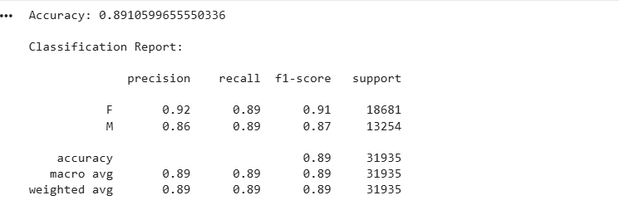

Screenshots Gender Predicting from Name
